Alla G. Vronskaya
Massachusetts Institute of Technology
State Institute for Art Studies, Moscow

Il’ia Golosov (1883-1945)
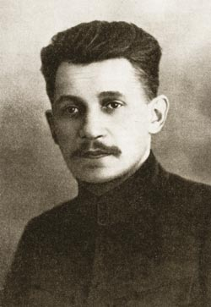
Il’ia Golosov
http://www.alyoshin.ru/Files/publika/khan_magomedov/khan_golosov_02.html
Il’ia Aleksandrovich Golosov, one of the leading Soviet modernist architects of the 1920s, was born in Moscow into the family of a priest and was the brother of architect Panteleimon Aleksandrovich Golosov (1882-1945). Alongside his brother, Il’ia Golosov graduated from Moscow Stroganov Art and Industry School in 1907 and from the Moscow School of Painting, Sculpture and Architecture in 1912, having received the degree of an architect. His first projects were private villas in various historical styles.
In 1919, Golosov became close to the members of Cubo-Futurist group Zhivskul’ptrarkh (an agglutination referring to Painting, Sculpture, Architecture), in particular architect NIKOLAI LADOVSKII, sculptor BORIS KOROLEV, and painter Nikolai Istselenov, who together with Golosov became members of the Sculpture Artel (Co-operative) of the Second Independent State Art Studios (soon to become famous as VKhUTEMAS) under the leadership of Korolev. Golosov’s early connection with Cubo-Futurism and sculpture had predicated his design principles and his formal vision of architecture. This sculptural attitude to architecture was manifested, in particular, in Golosov’s ‘theory of design of architectural organisms’: he interpreted architecture as a ‘mass’ (according to formalist aesthetics, a quintessentially sculptural property), or, in other words, as a large-scale form.
Golosov developed his architectural theory in the early 1920s, during the period of active pedagogical work at VKhUTEMAS, were he co-chaired an architecture workshop with KONSTANTIN MEL’NIKOV. The workshop was conceived as a middle-ground between the ultra-left workshop of Ladovskii and the workshops of architects-Classicists; the students of Golosov and Mel’nikov were encouraged to study the architecture of the past, but only in order to apprehend its ‘essence’—the principles of mass and form. Unlike his more left-wing colleagues, Golosov insisted on a subjectivity of architectural method and saw architecture as a creative art that requires genius and inspiration.
Although in the early 1920s Golosov worked in a Zhivskul’ptarkh-influenced style of the so-called Symbolic Romanticism, in 1925-28, at the period of an extreme popularity of CONSTRUCTIVISM, he accepted Constructivism’s formal language (without ever becoming its theoretician or officially joining the Constructivist group OSA) and quickly gained the reputation of one of the leading Constructivist architects. The most famous of Golosov’s buildings, the Zuyev Workers’ Club in Moscow (1927-29), is a sculpture-like play of interpenetrating volumes that recalls Golosov’s earlier theoretical principles. In the late 1920s and early 1930s Golosov was engaged in the design and planning of experimental urban and social projects (houses, communes and residential complexes), most notably, the residential complex in the First Workers’ Village in Ivanovo-Voznesensk (1930-32).
When modernist architecture was suppressed by the state in the early 1930s, Golosov returned to Classicism with apparent ease. Alongside other leaders of architectural profession, in 1933 he received his own architectural office (Moscow Soviet Workshop #4), which designed monumental buildings (mostly large residential complexes) as expressive volumetric compositions.
List of Works
1919 Crematorium in Moscow (competition entry).
1921 Radio Station; Observatory (unrealized projects).
1923 Pavilion of the Far East at the All-Russian Agricultural Exposition, Moscow.
1925 House of Textiles, Moscow (competition entry).
1927-29 Zuyev Workers’ Club, Moscow.
1928-30 The House of the Soviets, Khabarovsk.
1928-32 Government Building, Elista.
1930-32 Residential Block (‘The House of the Collective’) in the First Workers’ Village, Ivanovo-Voznesensk.
1933-35 Residential Complex on Iauzskii Boulevard, Moscow.
1936 Residential Building of the Car Factory, Gorky.
1938 Higher Trade Union School, Moscow.

References and Further Reading
Khan-Magomedov, S. O. (1988) Il’ia Golosov, Moscow: Stroiizdat (2nd edition: Moscow: Arkhitektura-S, 2007).
Khan-Magomedov, S. O. (1987), Pioneers of Soviet Architecture, New York: Rizzoli.

Visual Material

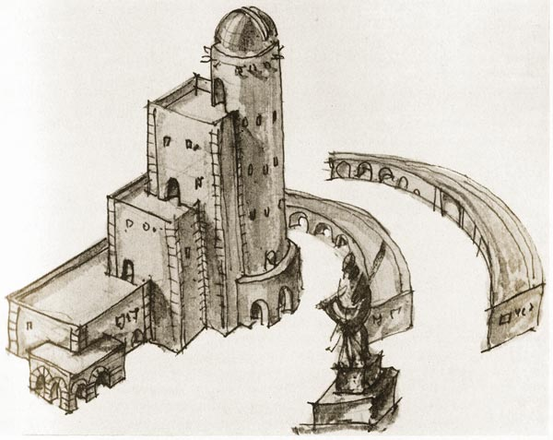
Observatory (1921)
http://www.alyoshin.ru/Files_ph/publika/khan_1/39.html

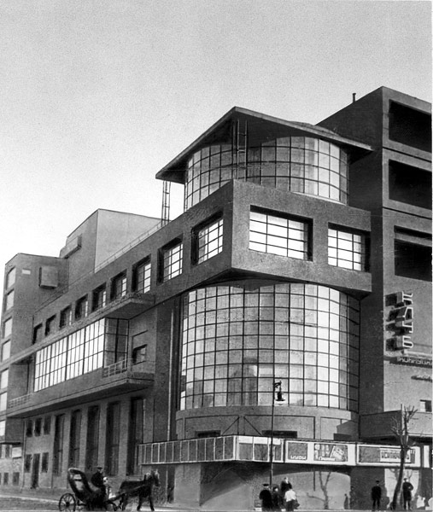
Zuyev Workers’ Club, Moscow (1927-29)
http://en.wikipedia.org/wiki/File:Zuev.jpg

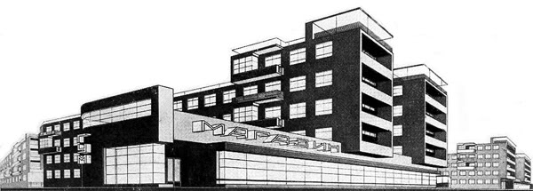
Residential Block in the First Workers’ Village, Ivanovo-Voznesensk. Realized version (1930-32)
http://archigrafo.livejournal.com/196062.html?thread=3392734

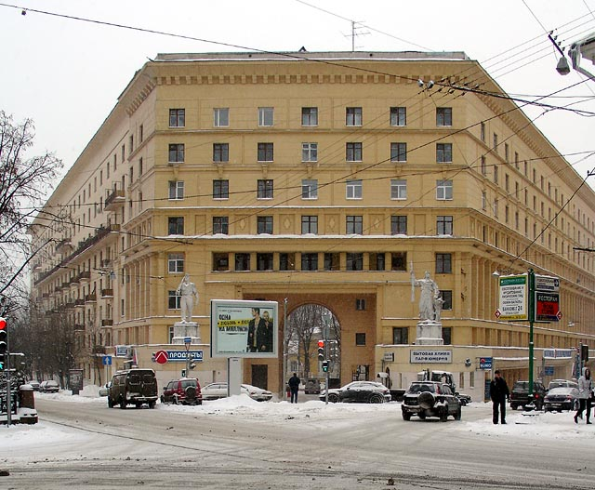
Residential Complex on Iauzskii Boulevard, Moscow (1933-35)
http://commons.wikimedia.org/wiki/File:Moscow_golosov.jpg?uselang=ru

